**SMART HOME TECHNOLOGY USING**

**AUGMENTED REALITY**

# A PROJECT REPORT

# NAAN MUDHALVAN

***Submitted by***

**PREM KUMAR S (412721106034)**

**in partial fulfillment for the award of the degree**

**of**

**BACHELOR OF ENGINEERING**

**IN**

# ELECTRONICS AND COMMUNICATION ENGINEERING



**TAGORE ENGINEERING COLLEGE**

**ANNA UNIVERSITY: CHENNAI 600 025**

# MAY 2024

**BONAFIDE CERTIFICATE**

Certified that this project report **“SMART HOME TECHNOLOGY USING AUGMENTED REALITY”** is the bonafide work of **“PREM KUMAR S (412721106034)** who carried out the project work under my supervision.

**SIGNATURE SIGNATURE**

## **Dr.P.RADHAKRISHNAN.M.E Ph.D., Mr.S.HARI RAMAKRISHNAN.,M.Tech.,**

**HEAD OF THE DEPARTMENT COURSE CO-ORDINATOR**

## **Department of ECE** **Department of ECE**

Tagore Engineering College Tagore Engineering College, Rathinamangalam Rathinamangalam,

Chennai – 127. Chennai – 127.

Submitted for the University Examination held on_______

# INTERNAL EXAMINER EXTERNAL EXAMINER

**ACKNOWLEDGEMENT**

I take this opportunity to extend my sincere and hearty thanks to our Chairperson **Prof. Dr.M.MALA.M.A.,(M.Phil).,** for providing as an opportunity and facilities to purpose our course in this institution.

I express my gratefulness to **Dr.R.RAMESH.M.E.,Ph.D.,** The Principal, Tagore Engineering College for this constant encouragement and guidance.

I express my special thanks to **Dr.P.RADHAKRISHNAN.M.E.,Ph.D.,** Professor and Head, Department of Electronics and Communication Engineering, Tagore Engineering College for the continuous support and guidance. I extend my cordial thanks to my course coordinator **Mr.S.HARI RAMAKRISHNAN.,M.Tech.,** Assistant Professorand my SPOC **Dr.R.PORSELVI M.E.,Ph.D.,** Senior Assistant ProfessorTagore Engineering College, for their role in completion of my project work.

I also thank all the faculty members, lab technicians and friends who have given us great moral support in the completion of my project.

**PREM KUMAR S**

# 

|  |  |  |
| --- | --- | --- |
|  | **TABLE OF CONTENTS** |  |
| **CHAPTER NO** | **TITLE** | **PAGE NO** |
|  | **ACKNOWLEDGEMENT** | III |
|  | **ABSTRACT** | IV |
|  | **SESSION REPORT**  Session – 1  Session – 2  Session – 3  Session – 4  Session – 5  Session – 6  Session – 7  Session – 8  Session – 9  Session – 10  Session – 11  Session – 12 | 1  1  2  3  4  5  6  7  8  9  10  11  12 |
| **1** | **INTRODUCTION** |  |
|  | 1.1 General | 13 |
|  | 1.2 Internet of Things | 14  14 |
|  | 1.3 Augmented Reality in 3D Viewers |
|  | 1.4 Proposed model |
| **2** | **METHODOLOGY** | 16 |
|  | 2.1 Introduction | 16 |
|  | 2.2 Smart Home environment design in UNITY | 16 |
|  | 2.2.1 Environment Layout | 16 |
|  | 2.3 SENSOR INTEGRATION WITH WOKWI  2.3.1 Sensor selection  2.3.2 Circuit Integration  2.3.3 Data Simulation | 17 |
|  | 2.4 Data Storage and Analysis with Thingspeak | 17 |

|  |  |  |
| --- | --- | --- |
|  | 2.4.1 Thingspeak setup  2.4.2 Data Transmission  2.5 Integration of Unity with Wokwi and Thingspeak  2.5.1 Wokwi Integration  2.5.2 Thingspeak Integration  2.6 Implementation of Smart Home Features  2.6.1 Device Control  2.6.2 Automation  2.7 Testing and Optimization  2.7.1 Functional Testing  2.7.2 Performance Optimization  2.8 Documentation and Presentation  2.8.1 Documentation  2.8.2 Presentation  2.9 Components  2.9.1 ESP 32  2.9.2 DHT 11  2.9.3 Ultrasonic Sensor  **SOFTWARE METHODOLOGY**  3.1 About Wokwi  3.2 About Thingspeak  3.3 About Unity  3.3.1 Android Environment Setup  3.3.2 Configuring the Android SDK path in Unity  3.3.3 Building Apps for Android  3.3.4 Configuring Build Settings  3.4 Text Compression  3.4.1 Build System  3.5 Configuring Player Settings  3.5.1 Identification  3.5.2 XR Settings  3.6 Build or Build and Run  3.6.1 About Power BI  **CHAPTER – 4**  4.1 Result and Discussion  **CHAPTER – 5**  5.1 Conclusion and Feature Scope | 17 |
|  | 17 |
|  | 18 |
|  | 18 |
|  | 18 |
|  | 18 |
|  | 18 |
|  | 18 |
|  | 18 |
|  | 18 |
|  | 19 |
|  | 19 |
|  | 19 |
| **3**  **4**  **5** | 19  19  19  20  21  23  23  24  26  27  27  28  28  29  29  30  30  31  31  32  33  33  34  34 |

# ABSTRACT

The Naan Mudhalvan Smart Home Technology project offers an immersive learning experience in the integration of Wokwi, ThingSpeak, and Unity to simulate and develop a smart home environment. Participants engage in designing and simulating sensor circuits using Wokwi, incorporating temperature, humidity, motion, and light sensors to replicate real-world smart home scenarios. This simulated sensor data is seamlessly transmitted to ThingSpeak, a cloud-based IoT platform, for real-time storage and analysis.

In Unity, participants create an interactive smart home environment, complete with a user interface for controlling and monitoring devices such as lights, appliances, and security systems. Unity serves as the hub for integrating Wokwi and ThingSpeak, facilitating the synchronization of simulated sensor data and enabling real-time interaction with the smart home environment.Throughout the project, emphasis is placed on practical application and experimentation. Participants explore various smart home scenarios and automation techniques, gaining valuable insights into IoT, simulation, and virtual environment development. By engaging in hands-on activities, participants develop skills in hardware simulations, cloud-based data storage, and virtual reality, while exploring the exciting potential of smart home technology. Overall, the Naan Mudhalvan Smart Home Technology project offers a unique opportunity for participants to delve into the world of IoT and smart home technology, equipping them with the knowledge and skills needed to innovate in this rapidly evolving field.

# SESSION REPORT

# SESSION -1

SESSION – 1 (05/02/2024) On the first day of the Naan Mudhalvan program, held on 05/02/2024, we delved into the intricacies of Industrial IoT as part of the comprehensive course curriculum. The session was particularly insightful as we had the privilege of learning directly from an industry expert. The focus of the day centered around project implementations, various projects we were going to da. The expert guided us through the process of IIOT, emphasizing its significance in industrial applications. Furthermore, the session included a detailed demonstration of IIOT. A key highlight was the practical aspect of linking these sensors to ThingSpeak, a prominent IoT platform. Through this integration, we witnessed real-time data transmission and visualization, particularly in the form of graphical outputs on the ThingSpeak software. This holistic approach not only reinforced theoretical concepts but also provided valuable insights into the practical aspects of Industrial IoT. Overall, the day proved to be instrumental in bridging the gap between theoretical knowledge, enhancing our understanding of the Industrial

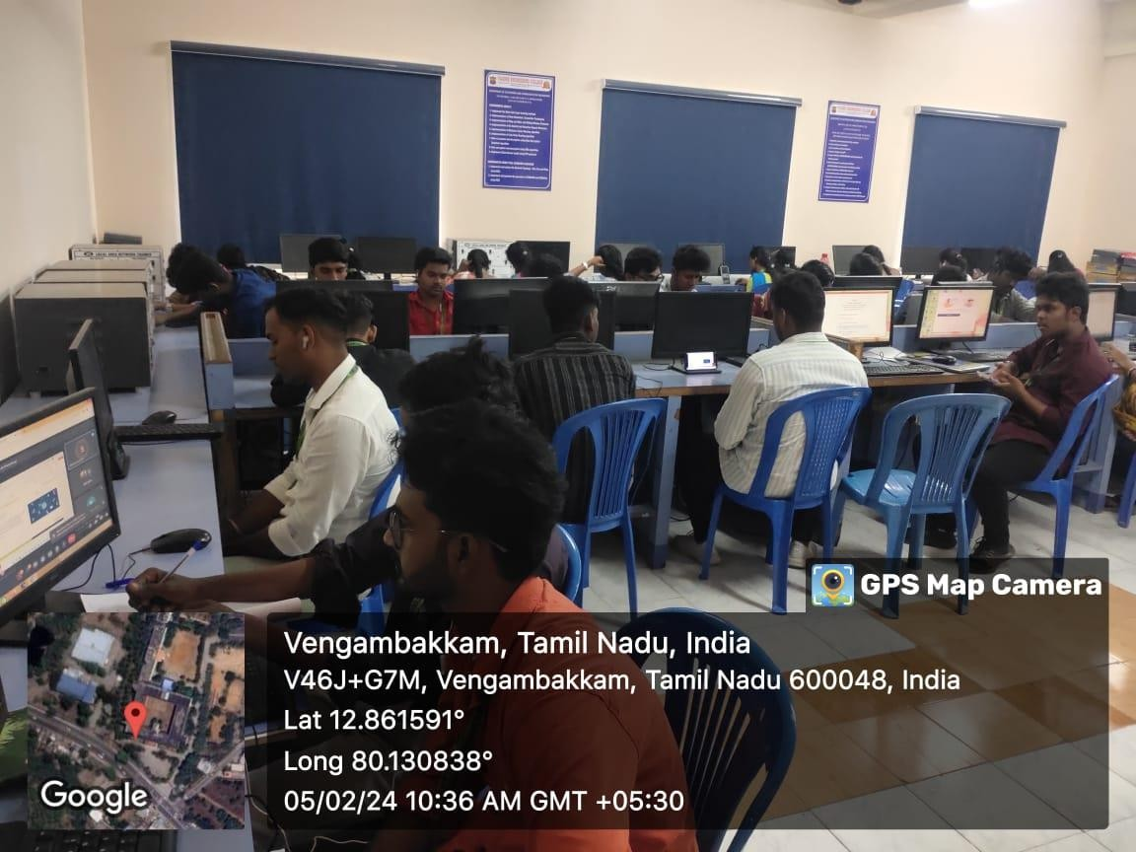

**Fig. Online Session**

**SESSION-2**

On the second day of the Naan Mudhalvan program, held on 12/02/2024, we delved into the intricacies of Wokwi an online simulation platform which can be used to simulate various circuits and board like Arduino, Raspberry etc. On this session we simulated various projects like LED glow, LED blink, Traffic Light using LED and Raspberry, we learned how to simulate various circuits and projects in wokwi and we learned to program using micro python. This session provided as with various useful insight.

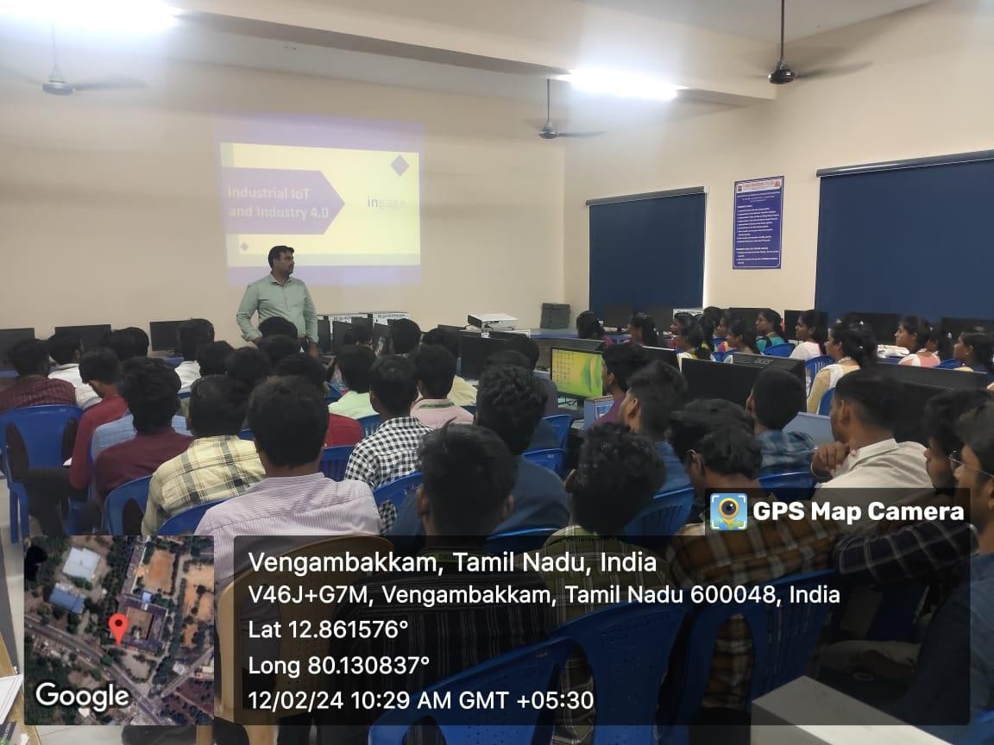

**Fig. Offline Session**

**SESSION – 3**

On the third day of the Naan Mudhalvan program, which took place on

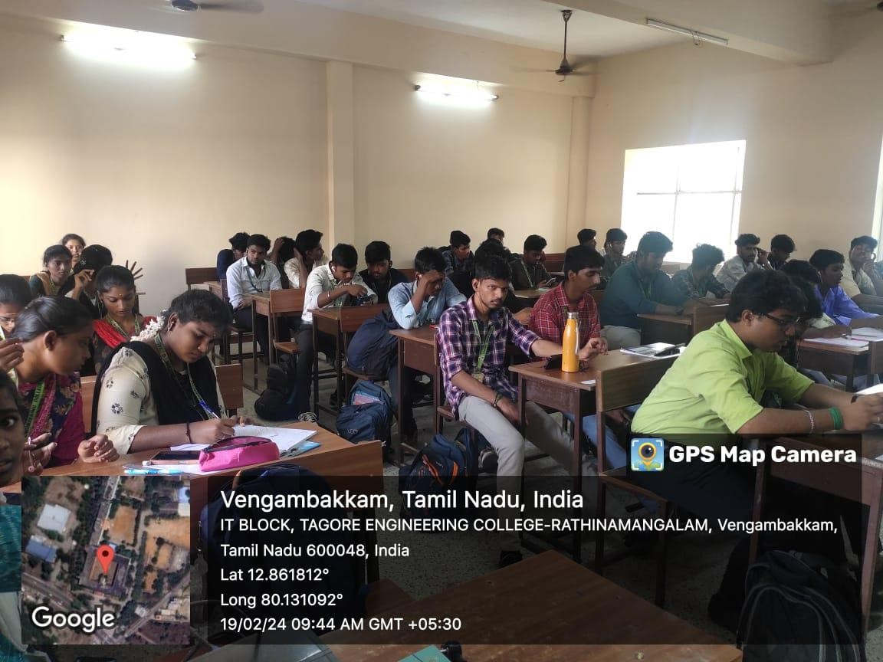19/03/2024, an enriching Ask Me Anything (AMA) session was conducted, proving to be a pivotal juncture in our learning journey. This session provided a platform for addressing and clarifying any lingering doubts stemming from the preceding day's Industrial IoT session. The industry expert led an engaging discussion, patiently responding to our queries and offering valuable insights, ensuring a comprehensive understanding of the concepts covered. Additionally, a significant portion of the session was dedicated to elucidating the details of the twelve projects slated for submission as part of the final project requirement.The expert meticulously explained the intricacies of each project, providing clarity on expectations, milestones, and key deliverables. This AMA session not only fostered a collaborative learning environment but also served as a roadmap for the successful completion of our final projects. Overall, the fifth day's session proved to be instrumental in fortifying our grasp on Industrial IoT concepts while paving the way for a focused and successful project completion

\

**Fig. Online Session**

**SESSION -4**

On the fourth day of the Naan Mudhalvan program, held on 26/02/2024, we delved into the intricacies of Industrial IoT as part of the comprehensive course curriculum. The session was particularly insightful as we had the privilege of learning directly from an industry expert. The focus of the day centered around practical project implementations, specifically on Wokwi platform. The expert guided us through the process of setting up a temperature sensor, the DHT22, emphasizing its significance in industrial applications. Furthermore, the session included a hands-on demonstration of integrating an ultrasonic sensor, demonstrating how to accurately calculate distance. A key highlight was the practical aspect of linking these sensors to ThingSpeak, a prominent IoT platform. Through this integration, we witnessed real-time data transmission and visualization, particularly in the form of graphical outputs on the ThingSpeak software. This holistic approach not only reinforced theoretical concepts but also provided valuable insights into the practical aspects of Industrial IoT. Overall, the day proved to b e instrumental in bridging the gap between theoretical knowledge and real-world applications, enhancing our understanding of the Industrial IoT landscape

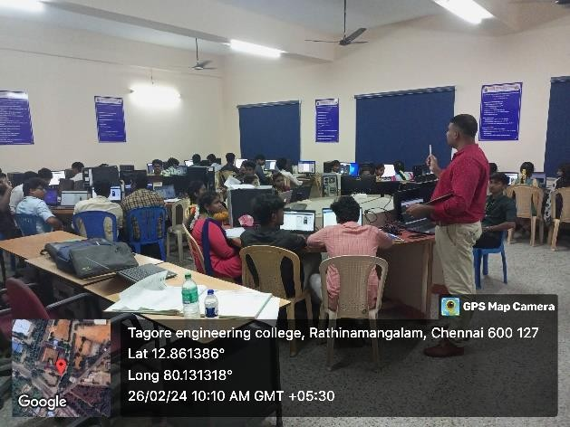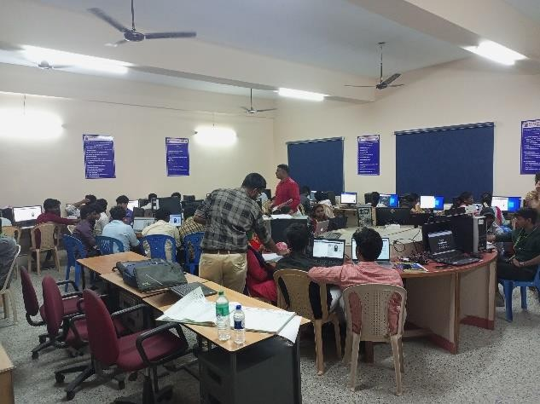

**Fig. Offline Session**

**SESSION – 5**

On the fifth day of the Naan Mudhalvan program, which took place on 04/03/2024, an enriching Ask Me Anything (AMA) session was conducted, proving to be a pivotal juncture in our learning journey. This session provided a platform for addressing and clarifying any lingering doubts stemming from the preceding day's Industrial IoT session. The industry expert led an engaging discussion, patiently responding to our queries and offering valuable insights, ensuring a comprehensive understanding of the concepts covered. Additionally, a significant portion of the session was dedicated to elucidating the details of the twelve projects slated for submission as part of the final project requirement. The expert meticulously explained the intricacies of each project, providing clarity on expectations, milestones, and key deliverables. This AMA session not only fostered a collaborative learning environment but also served as a roadmap for the successful completion of our final projects. Overall, the fifth day's session proved to be instrumental in fortifying our grasp on Industrial IoT concepts while paving the way for a focused and successful project completion.

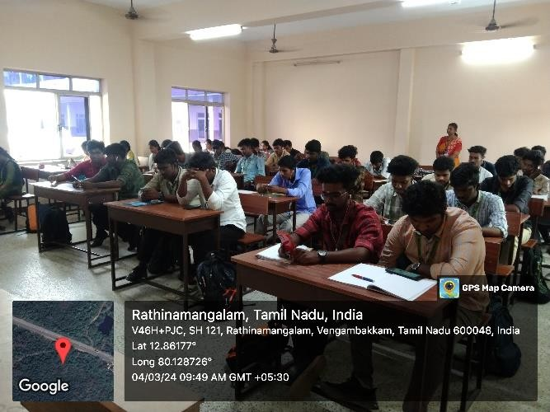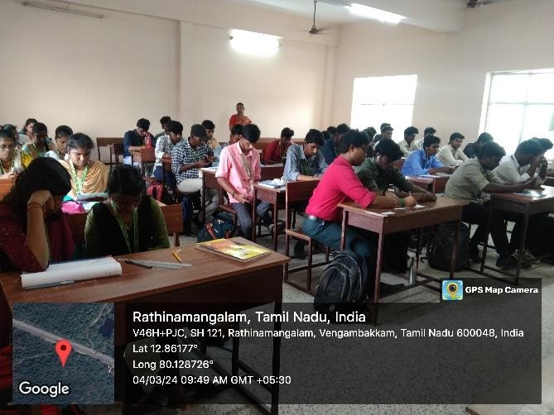

**Fig. Online Session**

# SESSION- 6

On the sixth session of the Naan Mudhalvan program, held on 11/03/2024 we delved into the Unity Hub, a centralized management tool for Unity projects and installations. The session commenced with an overview of Unity Hub's role in streamlining the Unity development process, offering features such as project organization, version control, and access to additional Unity services. Participants were introduced to the user interface, which boasts an intuitive design facilitating seamless navigation and project management. The session delved into the process of creating and managing Unity projects within the Hub, emphasizing best practices for organizing assets and collaborating with team members. Attendees gained insights into the version control features of Unity Hub, which enable efficient tracking of project revisions and facilitate collaboration among developers. Furthermore, the session highlighted the importance of utilizing Unity Hub's ability to manage multiple Unity installations, allowing developers to work with different versions of the engine simultaneously. This feature ensures compatibility with various projects and enables developers to take advantage of the latest Unity updates and features. In addition to project management and version control, the session explored the integration of Unity Hub with other Unity services, such as Unity Collaborate and Unity Analytics.

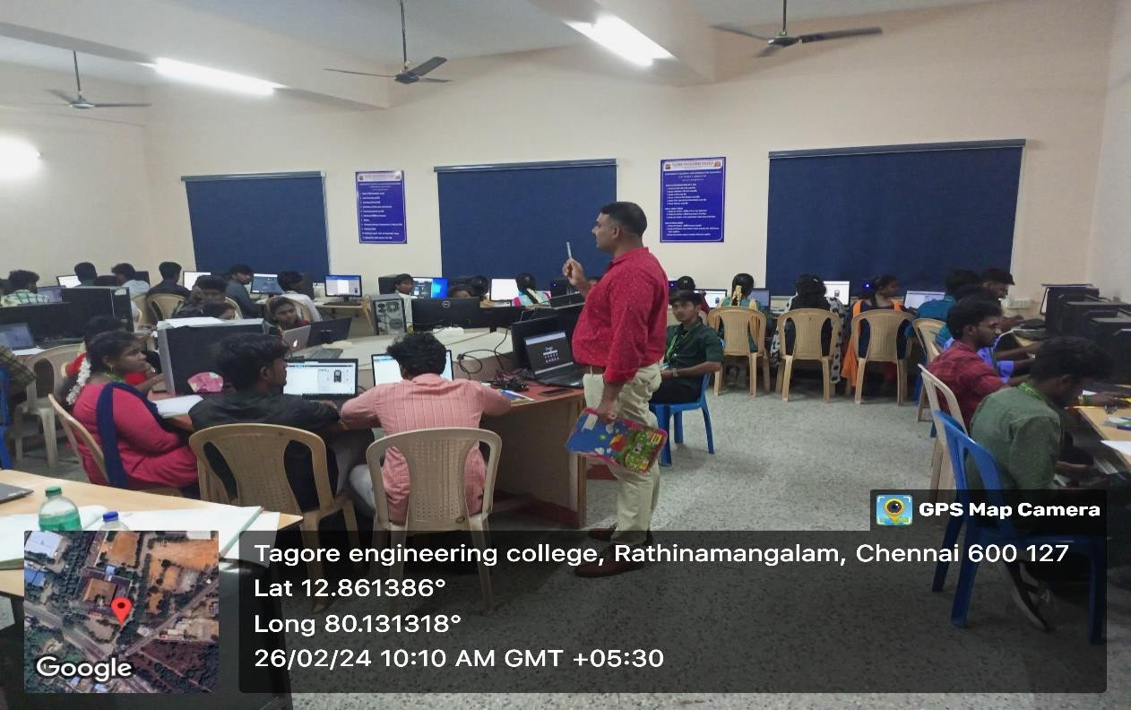

**Fig. Offline Session**

**SESSION - 7**

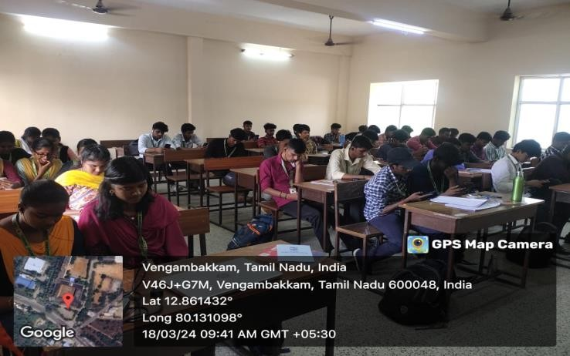On the Seventh session of Naan Mudhalvan program, held on 18/03/2024 we delved into the Ar Foundation, AR Foundation is a Unity framework that allows developers to create AR experiences that can run on both Android and iOS devices using a single codebase. It abstracts away the differences between AR Kit (Apple's AR framework) and AR Core (Google's AR framework), making it easier to develop cross-platform AR applications. AR Foundation enables developers to build AR applications that can run on both iOS and Android devices without having to rewrite the codebase for each platform. It provides feature parity between AR Kit and AR Core, allowing developers to access the same set of AR capabilities regardless of the underlying platform. AR Foundation supports a wide range of devices, including smart phones and tablets with compatible hardware for augmented reality. AR Foundation seamlessly integrates with the Unity game engine, enabling developers to leverage Unity's powerful tools and workflows for creating AR experiences. Overall, AR Foundation simplifies the process of developing AR applications by providing a unified framework for cross-platform development within the Unity ecosystem.

**Fig. Online Session**

# SESSION – 8

Wokwi and ThingSpeak are platforms used for different purposes, but they can be integrated for data transfer in certain scenarios.

Wokwi: It's an online platform for simulating and testing Arduino projects. You can write Arduino code, simulate it in a virtual environment, and see how it behaves.

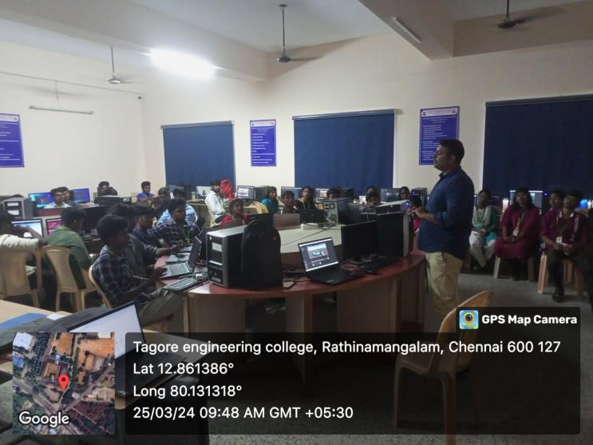ThingSpeak: It's an IoT platform that allows you to collect, analyze, and visualize data from IoT devices. It's commonly used with Arduino and other IoT devices to send sensor data to the cloud for storage and analysis.To transfer data from Wokwi to ThingSpeak, you would typically do the following:Write Arduino code in Wokwi that collects sensor data or any other relevant information.Use libraries such as ESP8266WiFi or Ethernet to connect your Arduino board to the internet. ConFigure the Arduino code to send the collected data to ThingSpeak using the ThingSpeak API. This usually involves making HTTP POST requests to ThingSpeak's server with the data you want to send. ThingSpeak provides you with a unique API key for your channel. Once the Arduino code is running on Wokwi and conFigured correctly, it will send the data to ThingSpeak, where you can visualize and analyze it using ThingSpeak's tools and services.This integration allows you to leverage Wokwi's simulation capabilities to test your Arduino code before deploying it to real hardware, and then seamlessly transfer the data to ThingSpeak for further analysis and visualization.

**Fig. Offline Session**

# SESSION – 9

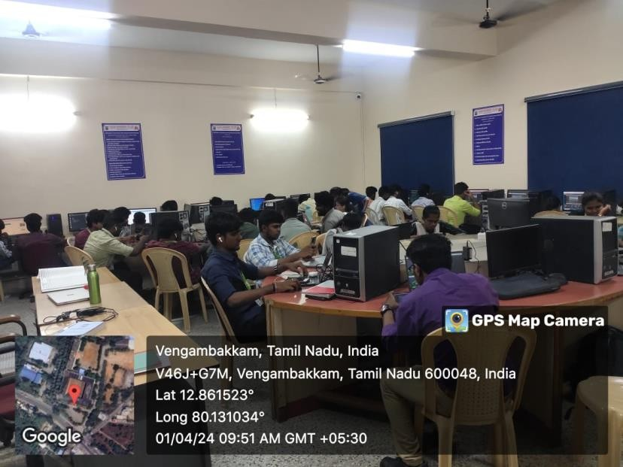The 9th day of Naan Mudhalvan which is in online, this session on integrating ThingSpeak and Wokwi with Unity. The session began by elucidating the significance of data visualization and real-time monitoring in Unity projects. Participants learned how ThingSpeak, a platform for IoT data collection, can be seamlessly integrated into Unity for data analysis and visualization. The instructors demonstrated step-by-step procedures for establishing a connection between ThingSpeak and Unity, enabling users to fetch and display real-time data within their Unity applications.Additionally, the session delved into leveraging Wokwi, a simulation platform for Arduino projects, within the Unity environment. Participants were introduced to the functionalities of Wokwi and guided through the process of incorporating Arduino simulations into Unity projects. This integration opened up avenues for creating immersive experiences that bridge the virtual and physical worlds, enhancing the interactivity and engagement of Unity applications. Overall, the session provided valuable insights and practical skills for leveraging ThingSpeak and Wokwi to augment the capabilities of Unity, empowering participants to create dynamic and data-driven experiences in their projects.

**Fig. Online Session**

# SESSION – 10

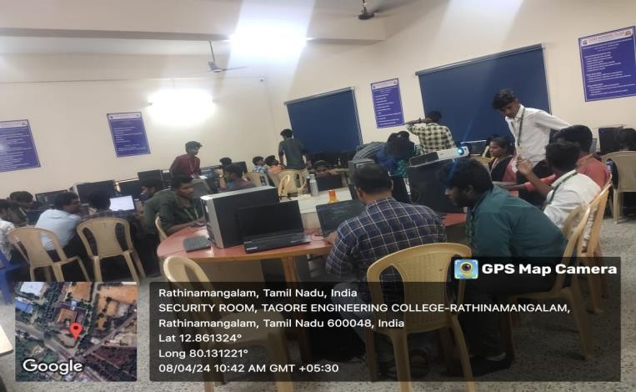During the Naan Mudhalvan offline session, participants were introduced to the robust capabilities of Power BI, a leading business intelligence tool. The session began with an overview of Power BI's data connectivity features, demonstrating its ability to seamlessly integrate with diverse data sources ranging from spreadsheets to complex databases. Subsequently, emphasis was placed on data modeling techniques within Power BI, highlighting the importance of establishing relationships between disparate data sets to optimize visualization outcomes. Moreover, participants gained insights into a myriad of visualization techniques offered by Power BI, empowering them to craft engaging and informative dashboards and reports Following the Power BI session, participants transitioned into the internal valuation phase of their Unity project. This pivotal segment of the offline session involved the comprehensive assessment of the projects developed by the participants using Unity. Meticulous evaluation, participants had the opportunity to showcase their proficiency in concepts, technical implementation, and creativity. The internal valuation process provided valuable feedback and constructive critique, facilitating the refinement and enhancement of participants' Unity projects. Development. Overall, the internal valuation phase marked a significant milestone in the Naan Mudhalvan course, encapsulating the culmination of participants' efforts and dedication towards mastering Unity game development.

**Fig. Offline Session**

# SESSION – 11

The 11th day of Naan Mudhalvan which is an online session encompassing various aspects from its inception to advanced topics. Beginning with an introduction to Unity, participants gained insights into its versatile capabilities for game development and simulation. Subsequently, the course navigated through the integration of ThingSpeak, a platform for real-time data collection and analysis, with Unity. Through comprehensive tutorials, attendees learned to interface ThingSpeak with Unity, enabling the seamless integration of real-world data into Unity applications, thus enhancing their functionality and realism. Moreover, the session delved into the integration of Wokwi, a simulation platform for Arduino projects, with Unity. Participants were guided through the process of incorporating Wokwi simulations into Unity environments, facilitating the creation of immersive experiences that bridge virtual and physical worlds. Through practical demonstrations, attendees learned how to leverage Power BI to analyze and visualize data collected from ThingSpeak within Unity applications, thereby enhancing the understanding and utilization of real- time data in Unity projects. Overall, the session provided a holistic view of integrating ThingSpeak, Wokwi, and Power BI with Unity, equipping participants with the skills to create dynamic and data-driven experiences in their projects.

**Fig. Online Session**

# SESSION – 12

The final offline session of Naan Mudhalvan marked a significant milestone in the program's journey, encapsulating the participants' culmination of learning and practical application. The session centered around a comprehensive assessment designed to gauge their understanding and proficiency in key areas of unity, Wokwi, and ThingSpeak.The assessment also delved into the practical application of Wokwi, an innovative platform for hardware simulation and prototyping. Participants were evaluated on their ability to navigate Wokwi's features effectively, simulate hardware components, and develop prototypes that meet specified criteria. This segment of the assessment aimed to assess participants' technical skills and their capacity to translate theoretical knowledge into practical solutions.

Furthermore, the evaluation extended to ThingSpeak, an IoT platform enabling data collection, analysis, and visualization. Participants were tasked with demonstrating their understanding of ThingSpeak's functionalities, including data streaming, visualization, and integration with other platforms. Through this segment, participants were assessed on their ability to harness the power of IoT technology for real-world applications, such as environmental monitoring, smart agriculture, and industrial automation.Overall, the final assessment served as a comprehensive measure of participants' knowledge and skills acquired throughout the Naan Mudhalvan program.

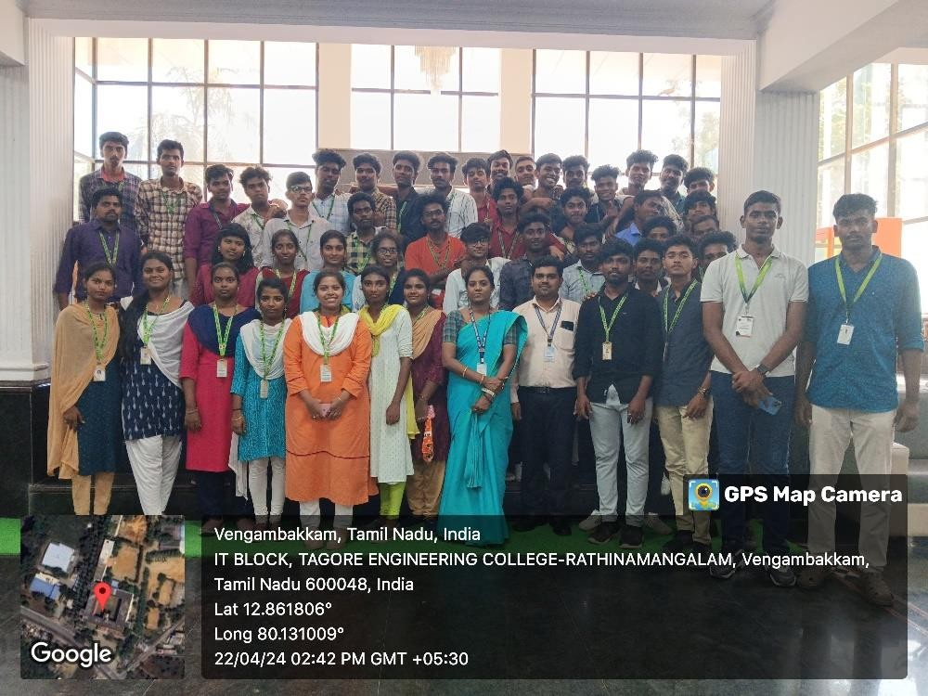

**Fig. Offline Session**

**CHAPTER 1**

**INTRODUCTION**

# 1.1 GENERAL

In today's rapidly advancing technological landscape, the concept of a "SMART HOME " has emerged as a cornerstone of modern living. Integrating cutting-edge technologies into everyday domestic environments, smart homes offer unprecedented levels of convenience, efficiency, and security. With the advent of Unity, a powerful game development platform, coupled with Wokwi and ThingSpeak for data monitoring, the possibilities for creating immersive and intelligent home environments have expanded exponentially. At the heart of this project lies Unity, a versatile tool renowned for its ability to create stunning 3D simulations and interactive experiences. Leveraging Unity's capabilities, developers can construct lifelike virtual environments that mimic real-world settings with remarkable fidelity. As an Internet of Things (IoT) platform, ThingSpeak allows for the collection, storage, and visualization of sensor data in real time. By integrating ThingSpeak into the Unity environment, developers can create dynamic dashboards and displays that provide users with insights into various aspects of their smart home, from temperature and humidity levels to energy consumption and security status. In essence, this project represents a convergence of innovative technologies aimed at revolutionizing the way we interact with our living spaces. By combining the immersive capabilities of Unity, the prototyping prowess of Wokwi, and the data monitoring functionalities of ThingSpeak, developers have the tools they need to create next-generation smart home experiences that are both intelligent and intuitive. As we journey into the era of the Internet of Things, projects like this one serve as a testament to the boundless potential of technology to enhance our daily lives in meaningful ways.

**1.2 INTERNET OF THINGS**

IOT means Internet of Things. It is very tough to de- fine IoT. The topic IoT has been used by Kevin Ashton. IoT is a network of internet-linked action capable of gather of data or information. Many computing devices are embedded with our necessary appliances to the internet through IoT. IoT term has two major parts

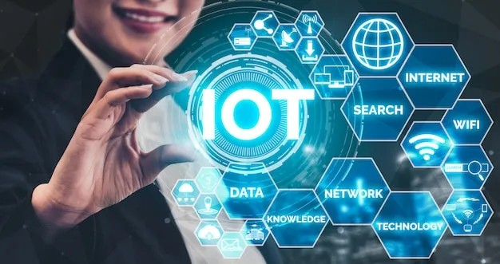

**Fig 1:** IOT Based Home Automation System.

* Internet is the backbone of connectivity.
* Things meaning object.

The term internet of things is a concept but it is not specific hardware or software or electronics. With the introduction of IoT, the home automation systems are becoming more famous at present days research. Through the internet of things, it is possible to control and monitor home appliances.

# 1.3AUGMENTED REALITY IN 3D VIEWERS

This allows users to put life-size 3D models in their environment with or without the use of trackers. Trackers are the simple images that 3D models can be linked-to in Augmented Reality.

**1.4 PROPOSED MODEL**

In our, we’re aiming to fuse Unity with Wokwi and ThingSpeak to create a comprehensive simulation platform for smart home technology. Within this integrated system, Unity serves as the virtual environment where you'll replicate various aspects of a smart home setup. Wokwi's integration allows for the simulation of Arduino-based devices, enabling you to emulate smart devices like locks, sensors, and actuators within Unity. Meanwhile, ThingSpeak acts as the data collection and analysis hub, gathering information from these virtual devices and providing tools for visualization. This setup facilitates the testing and refinement of Arduino code in a simulated environment before deploying it to physical hardware. With user interaction mechanisms and automation logic implemented within Unity, you can simulate realistic smart home scenarios and observe how different devices interact. Ultimately, this project offers a robust platform for experimenting with and optimizing smart home systems in a virtual space before real-world implementation.

**CHAPTER – 2**

**METHODOLOGY**

**2.1 INTRODUCTION**

Provide an overview of the methodology, explaining the objective of creating a simulated smart home environment using Unity, integrating sensor simulations with Wokwi, and storing and analyzing data in ThingSpeak.

Emphasize the importance of smart home technology in modern living and the practical skills participants will gain from the project.

**2.2 SMART HOME ENVIRONMENT DESIGN IN UNITY**

**2.2.1 Environment Layout**

* Design the layout of the smart home environment using Unity's scene editor.
* Define rooms, furniture, appliances, and interactive elements such as lights, switches, and sensors.

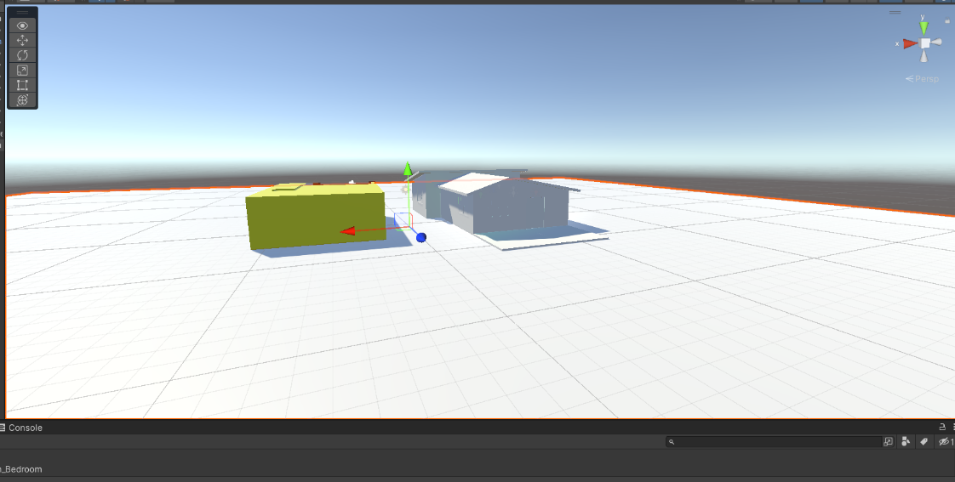

**Fig 2.1** Home Environment in Unity

**2.3 SENSOR INTEGRATION WITH WOKWI**

**2.3.1 Sensor Selection**

* Choose sensors compatible with Wokwi's simulation platform and suitable for smart home applications.
* Select sensors for monitoring temperature, humidity, motion, light, and other relevant parameters.

**2.3.2 Circuit Integration**

* Integrate sensor simulations into the Wokwi environment to mimic real-world sensor behavior.
* Connect sensors to appropriate components within the smart home environment in Wokwi.

**2.3.3 Data Simulation**

* Simulate sensor data readings within Wokwi to generate realistic data for the smart home environment.
* Implement algorithms to simulate sensor responses to environmental changes and user interactions.

**2.4 DATA STORAGE AND ANALYSIS WITH THINGSPEAK**

**2.4.1 Thing Speak Setup**

* Create Thing Speak channels for storing sensor data and defining data fields.
* Set up Thing Speak plugins for data visualization and analysis, such as MATLAB Visualizations.

**2.4.2 Data Transmission**

* Configuring Wokwi to transmit simulated sensor data to ThingSpeak channels in real-time.
* Implement data logging mechanisms to store sensor data in ThingSpeak for further analysis.

**2.5 INTEGRATION OF UNITY WITH WOKWI AND THINGSPEAK**

**2.5.1 Wokwi Integration**

* Establish communication between Unity and Wokwi platforms to synchronize simulated sensor data with the Unity environment.
* Use networking protocols or custom APIs to exchange data between Unity and Wokwi.

**2.5.2 ThingSpeak Integration**

* Retrieve real-time sensor data from ThingSpeak channels within the Unity environment.
* Visualize sensor data in Unity to provide feedback to the user and enable interactive control of smart home devices.

**2.6 IMPLEMENTATION OF SMART HOME FEATURES**

**2.6.1 Device Control**

* Implement functionality for controlling smart home devices based on user input and sensor data.
* Enable users to turn lights on/off, adjust thermostat settings, and activate security systems through the Unity interface.

**2.6.2 Automation**

* Develop automation scripts to automate tasks based on predefined conditions and sensor readings.
* Implement scenarios such as turning on lights when motion is detected or adjusting temperature settings based on environmental conditions.

**2.7 TESTING AND OPTIMIZATION**

**2.7.1 Functional Testing**

* Conduct thorough testing of the integrated system to ensure proper functionality and data accuracy.
* Test user interactions, sensor responses, and data transmission between Unity, Wokwi, and ThingSpeak.

**2.7.2 Performance Optimization**

* Optimize the performance of the smart home simulation by minimizing latency and resource usage.
* Identify and address any bottlenecks or inefficiencies in data transmission and processing.

**2.8 DOCUMENTATION AND PRESENTATION**

**2.8.1 Documentation**

* Document the methodology, implementation details, and code documentation for future reference.
* Provide instructions for setting up and running the smart home simulation project.

**2.8.2 Presentation**

* Prepare a presentation or demonstration showcasing the smart home simulation project.
* Highlight key features, functionalities, and innovations implemented using Unity, Wokwi, and ThingSpeak.

**2.9 COMPONENTS**

**2.9.1** **ESP32**: The ESP32 is a versatile microcontroller widely used in IoT and embedded applications due to its powerful processing capabilities, low power consumption, and built-in Wi-Fi and Bluetooth connectivity. It features dual-core processors, ample RAM, and flash memory, and a rich set of peripheral interfaces, making it well-suited for handling various tasks in smart home systems. With its ability to connect to the internet and communicate with other devices, the ESP32 serves as the central control unit for your smart home setup, facilitating data collection, processing, and device control.

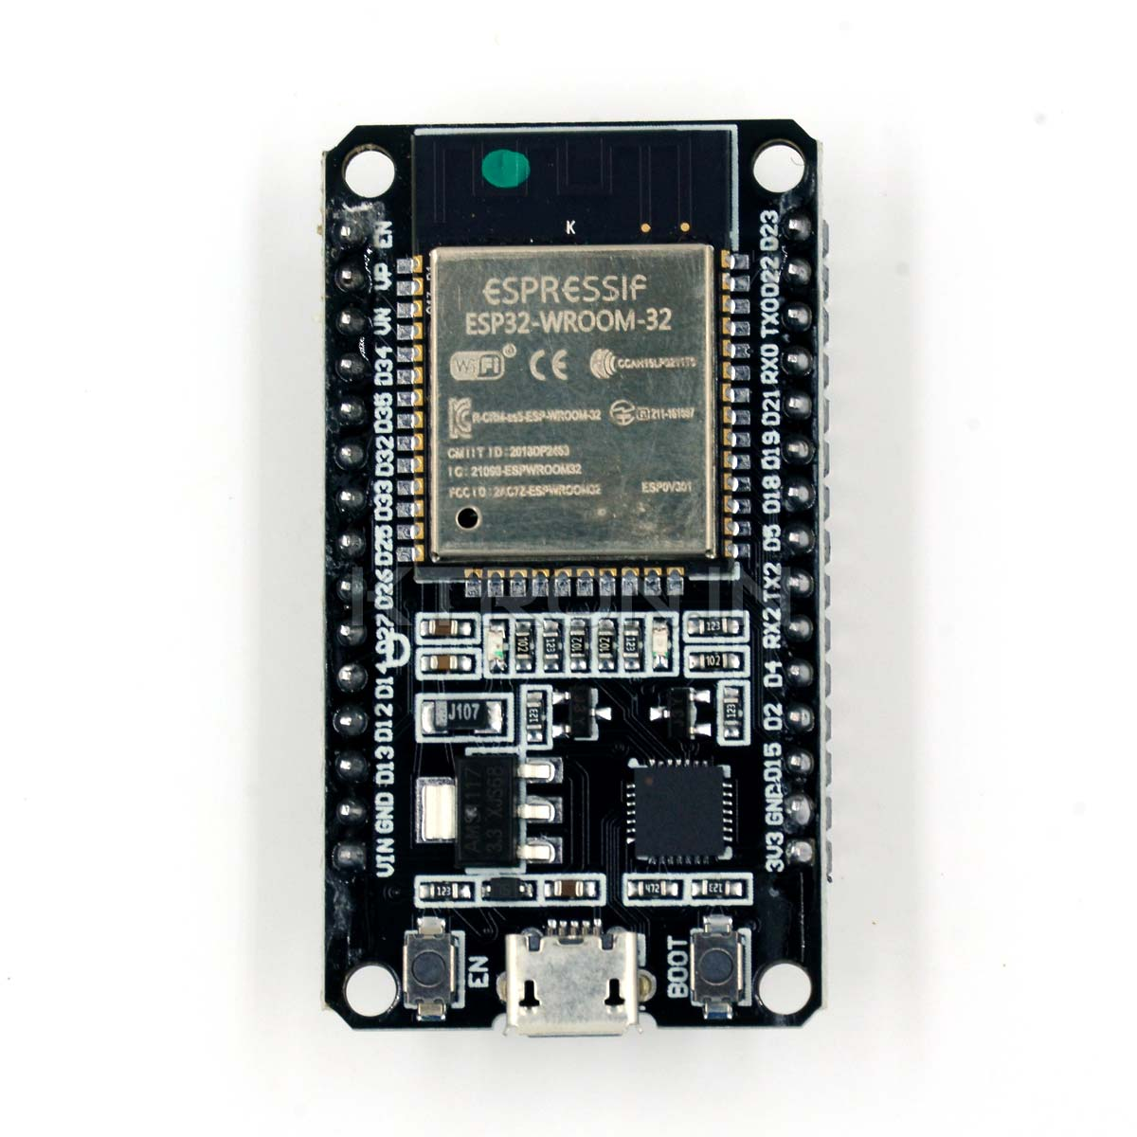

**Fig 2.2 ESP32**

**2.9.2 DHT11 Sensor**: The DHT11 is a basic digital temperature and humidity sensor thatprovides reliable and low-cost environmental sensing capabilities. It consists of a capacitive humidity sensor and a thermistor to measure temperature. The DHT11 communicates with the ESP32 using a simple digital protocol, making it easy to interface with microcontrollers. In your smart home project, the DHT11 sensor enables monitoring of indoor climate conditions, allowing you to maintain comfortable and healthy living environments by adjusting heating, ventilation, and air conditioning systems as needed.

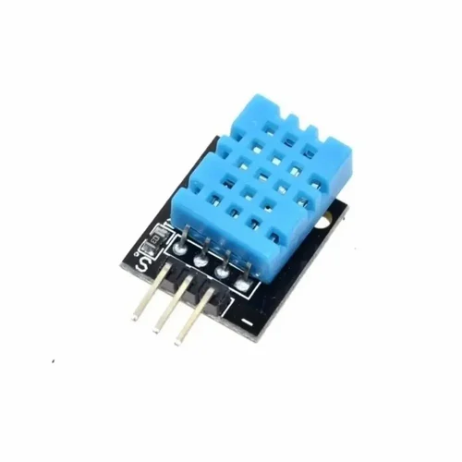

**Fig 2.3 DHT11 Sensor**

**2.9.3 Ultrasonic Sensor**: The ultrasonic sensor uses sound waves to measure distances to nearby objects accurately. It typically consists of a transmitter and a receiver, which work together to emit ultrasonic pulses and detect their reflections off nearby surfaces. By measuring the time it takes for the sound waves to travel to the object and back, the ultrasonic sensor can calculate the distance with high precision. In your smart home project, the ultrasonic sensor adds spatial awareness to the ESP32, enabling the detection of nearby objects or obstacles.

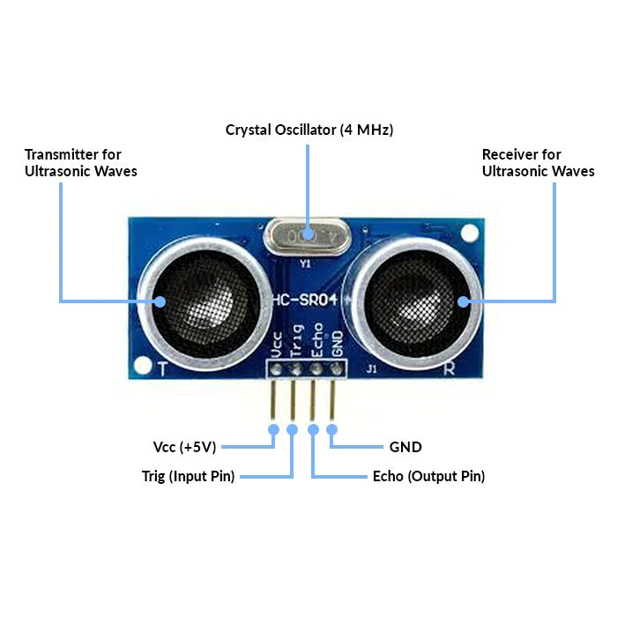

**Fig 2.4 Ultrasonic Sensor**

This capability is useful for applications such as occupancy detection, security monitoring, and object avoidance in home automation systems.

Together, the ESP32 microcontroller, DHT11 temperature and humidity sensor, and ultrasonic sensor form the foundation of your smart home technology project enabling data collection, environmental monitoring, and intelligent decision-making for enhanced comfort, convenience, and security in residential environments.

Overall, the integration of an ultrasonic sensor into a smart home project expands the capabilities of the ESP32 microcontroller by providing spatial awareness and enabling a range of applications related to environmental monitoring, occupancy detection, security, and automation. By leveraging the combined functionality of multiple sensors and intelligent data processing algorithms, the smart home system can deliver enhanced comfort, convenience, and security for residents.

**CHAPTER 3**

**SOFTWARE METHODOLOGY**

**3.1 ABOUT WOKWI**

Wokwi allows you to simulate Arduino code online without the need for physical hardware. This capability is invaluable for smart home technology development because it enables you to test your code in a virtual environment before deploying it to real devices. We can simulate various smart home components, such as sensors, actuators, and communication modules, to ensure they function as expected.



**Fig 3.1 Wokwi image**

Combining a DHT11 temperature and humidity sensor with an ultrasonic sensor on a single ESP32 microcontroller opens up a range of possibilities for smart home applications. The DHT11 sensor provides accurate readings of temperature and humidity levels, while the ultrasonic sensor measures distances using sound waves. This combination enables the ESP32 to gather environmental data and detect nearby objects simultaneously, enhancing the intelligence and versatility of smart home systems.With the DHT11 sensor, the ESP32 can monitor indoor climate conditions, allowing users to maintain optimal temperature and humidity levels for comfort and health. By integrating this data into smart home automation systems, users can automate actions such as adjusting thermostats, controlling humidifiers or dehumidifiers, and triggering alerts for abnormal conditions.

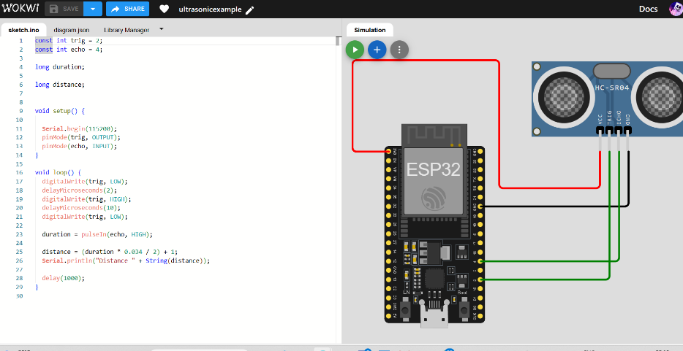

**Fig 3.2 Simulation using sensors**

**3.2 ABOUT THINGSPEAK**

ThingSpeak acts as a bridge between virtual simulations created in Wokwi and real-time data visualization, providing a seamless transition from simulation to practical application in smart home technology. In the Wokwi environment, virtual Arduino-based projects, including sensors like DHT11 and ultrasonic sensors, generate simulated data representing temperature, humidity, and distance measurements. This data is then transmitted to ThingSpeak via MQTT (Message Queuing Telemetry Transport) or HTTP protocols, allowing ThingSpeak to collect and store it in real-time.



**Fig 3.3 Thingspeak Logo**

Once the data is received, ThingSpeak's data visualization tools come into play, offering various graphical representations such as line charts, bar graphs, and gauges to visualize the collected data. Users can customize these visualizations to suit their preferences and requirements, adjusting parameters like time range, scaling, and appearance. For example, temperature and humidity readings from the DHT11 sensor can be plotted on a line chart over time, providing insights into environmental fluctuations. Similarly, distance measurements from the ultrasonic sensor can be displayed as a bar graph, showing changes in proximity to objects over time. These graphical representations not only make it easier for users to interpret the data but also facilitate trend analysis, anomaly detection, and decision-making in smart home applications. Overall, the integration of Wokwi with ThingSpeak enables a seamless transition from virtual simulation to real-world implementation, empowering users to develop, test, and deploy smart home solutions with confidence.

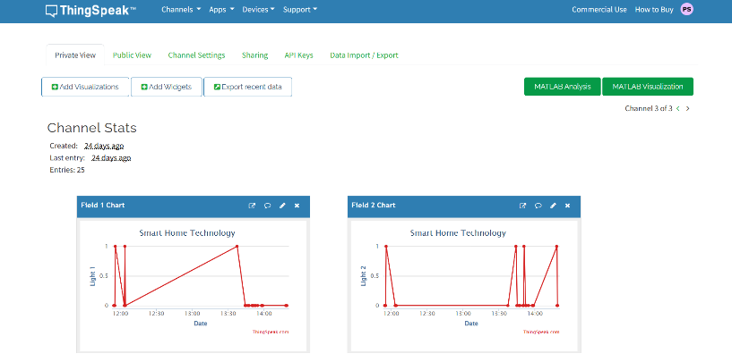

**Fig 3.4.1 Thingspeak channel status 1**

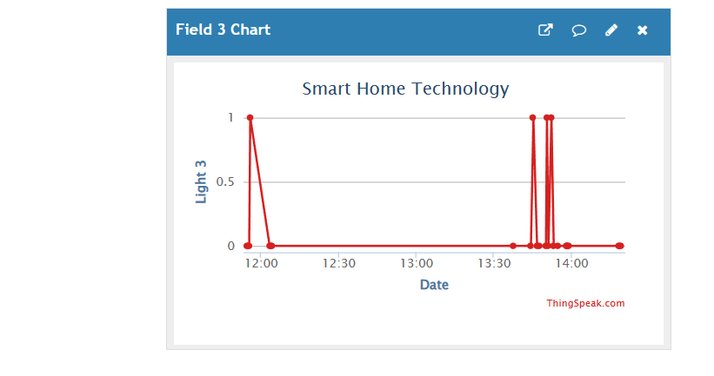

**Fig 3.4.2 Thingspeak channel status 2**

**3.3 ABOUT UNITY**

Unity Technologies has developed a widely popular cross-platform game engine, known as Unity. Initially released in June 2005 at Apple Inc.'s Worldwide Developers Conference, it was exclusively for Mac OS X. However, the engine has since expanded to support over 25 platforms. Unity is highly versatile and can be used to create a wide range of games, from 3D and 2D to virtual and augmented reality games, simulations, and other experiences. The engine has also been adopted by various industries beyond gaming, including film, automotive, architecture, engineering, and construction.

Unity's primary scripting API is in C#, which can be used for both the Unity editor in the form of plugins and games themselves, as well as drag and drop functionality. Previously, Unity supported Boo as its primary programming language, but it was removed in Unity 5. Unity Script, a version of JavaScript, was also deprecated in August 2017 after the release of Unity 2017.1 in favor of C#.

For 2D games, Unity allows the importation of sprites and an advanced 2D world renderer. For 3D games, Unity offers the specification of texture compression, mipmaps, and resolution settings for each platform that the game engine supports. Additionally, it provides support for various features, including bump mapping, reflection mapping, parallax mapping, screen space ambient occlusion (SSAO), dynamic shadows using shadow maps, render-to-texture, and full-screen post-processing effects.

Unity is a popular choice for game development, with approximately half of new mobile games and 60 percent of augmented reality and virtual reality content being created using Unity as of 2018. The engine's logo is displayed below in Figure 2.1.



**Fig 3.5 Unity logo**

**3.3.1 ANDROID ENVIRONMENT SETUP**

Whether one is building an Android application in Unity or programming it from scratch, one must set up the Android Software Development Kit (SDK) before one can build and run any code on the Android device.

• Install the Java Development Kit

• Install the Android SDK using Android Studio

**3.3.2 CONFIGURING THE ANDROID SDK PATH IN UNITY**

The first time you create a Project for Android (or if Unity later fails to locate the SDK), Unity asks you to locate the folder in which you installed the Android SDK. If you installed the SDK using the SDK manager, you can find the folder in <android tools install location>\platforms\<android sdk folder>.

Example: c:\<android tools install location>\platforms\android–27

If you installed the SDK when you installed Android Studio, you can find the location in the Android Studio SDK Manager. To open the SDK Manager from Android Studio, click Tools > Android > SDK Manager or click SDK Manager in the toolbar.

To change the location of the Android SDK, in the menu bar go to Unity > Preferences > External Tools. The SDK manager toolbar button icon is shown in Fig 2.2.



**Fig 3.6 SDK manager toolbar button**

**3.3.3 BUILDING APPS FOR ANDROID**

There are two locations to configuring settings that affect how the app is built:

• Player Settings - Allows to configuring runtime settings for the app.

• Build settings - Allows to configuring build system parameters and build the app.

**3.3.4 CONFIGURING BUILD SETTINGS**



**Fig 3.7 Build settings**

Fig 2.3 shows the build settings window. To conFigure and build apps for Android, access the Build Settings window, and select File > Build Setting. In Platforms, select Android. To set Android as the default build platform.

**3.4 TEXTURE COMPRESSION**

The Unity Android build system supports the following texture compression format options: Don’t override, DXT (Tegra), PVRTC (PowerVR), ETC (default), ETC2 (GLES 3.0), and ASTC. Unity uses the Ericsson Texture Compression (ETC) format for textures that don’t have individual texture format overrides. When building an APK to target specific hardware, use the Texture Compression option to override this default behavior. Texture Compression is a global setting for the Project. If a texture has a specific override on it, that texture is not affected by the Texture Compression setting. Here choose Don’t override option.

**3.4.1 BUILD SYSTEM**

Unity supports two Android build systems: Gradle and Internal. The steps involved with building for Android are:

• Preparing and building the Unity Assets

• Compiling scripts.

• Processing the plug-ins.

• Splitting the resources into the parts that go to the APK and the OBB, if Split Application Binary is selected.

• Building the Android resources using the AAPT utility (internal build only.)

• Generating the Android manifest.

• Merging the library manifests into the Android manifest (internal build only.)

• Compiling the Java code into the Dalvik Executable format (DEX) (internal build only.)

• Building the IL2CPP library, if IL2CPP Scripting Backend is selected.

• Building and optimizing the APK and OBB packages.

Gradle build system: The Gradle build system uses Gradle to build an APK or export a Project in Gradle format, which can then be imported to Android Studio. When you select this build system, Unity goes through the same steps as the Internal build system excluding resource compilation with AAPT, merging manifests, and running DEX. Unity then generates the build. gradle file (along with the other required conFiguration files) and invokes the Gradle executable, passing it the task name and the working directory. Finally, the APK is built by Gradle.

Internal build system: The Internal build system creates an APK using the Android SDK utilities to build and optimize the APK and OBB packages. For more information about OBB files, see OBB Support.

Here in this project, Internal build system option is chosen.

**3.5 CONFIGURING PLAYER SETTINGS**

This page details the Player Settings specific to Android. For a description of the general Player Settings, see documentation and images included on Player Settings that follows.

**3.5.1 IDENTIFICATION**

The below Fig 2.4 shows the identification section of the player settings in unity.



**Fig 3.8 Identification section of player settings**

• Package Name: The unique application ID, used to uniquely identify your app on the device and in Google Play Store. (Shared between iOS and Android.)

• Version: Specifies the build version number of the bundle, which identifies an iteration (released or unreleased) of the bundle. The version is specified in the common format of a string containing numbers separated by dots (e.g., 4.3.2). (Shared between iOS and Android.)

• Minimum API Level: Minimum Android version (API level) required to run the application

• Target API Level: Target Android version (API level) against which to compile the application.

**3.5.2 XR SETTINGS**



**Fig 3.9 XR Settings section in Player Settings**

• Vuforia Augmented Reality: Above Fig 2.5 shows the XR settings section. Enable the use of the Vuforia Software Development Kit. One must have a Vuforia Software License and agree to the terms of that license before the property becomes enabled.

**3.6 BUILD OR BUILD AND RUN**

The Build Settings window offers two options: Build and Build and Run. Using either option saves the output packages (APK and OBB, if enabled) to the path that one selects. One can publish these packages to the Google Play Store, or install them on the device manually with the help of Android Debug Bridge (ADB). Selecting Build and Run saves the output packages to the file path specified, while also installing the app on the Android device connected to the computer.

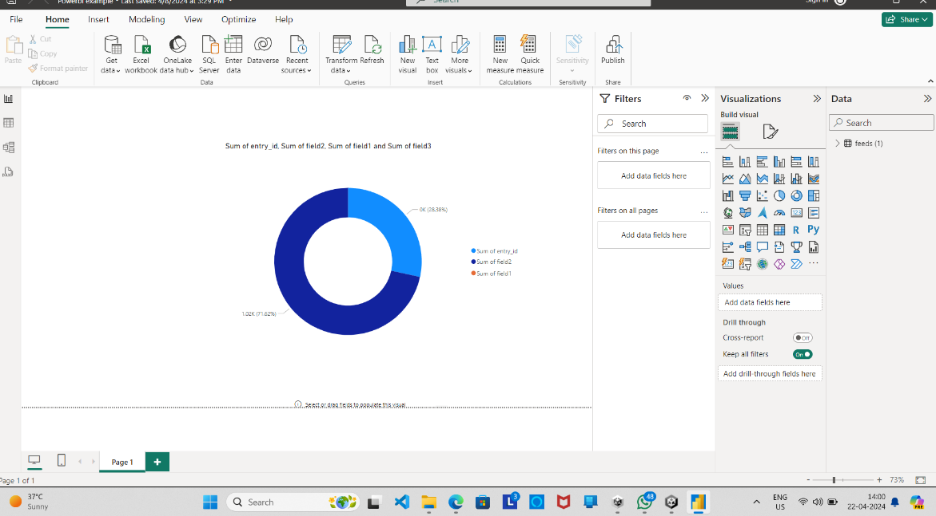

**Fig 3.10 Power BI Output**

**3.6.1 ABOUT POWER BI**

Power BI plays a pivotal role in shaping the landscape of smart home technology through its robust capabilities in data visualization and analytics. At the heart of the smart home ecosystem lies a multitude of interconnected devices, each generating a stream of data. Power BI serves as the central hub for aggregating, analyzing, and presenting this data in a coherent and actionable manner. Its real-time monitoring features empower users to stay abreast of their smart home's status and performance, enabling timely interventions when necessary. Custom dashboards tailored to individual preferences offer a holistic view of the smart home environment, allowing us to track key metrics and trends effortlessly. Moreover, Power BI's predictive analytics capabilities enable proactive measures, such as predicting maintenance needs or optimizing energy usage based on historical data. By integrating seamlessly with other smart home systems, Power BI enhances interoperability and streamlines the management of interconnected devices. In essence, Power BI empowers homeowners to harness the full potential of their smart home technology, promoting convenience, efficiency, and peace of mind in modern living spaces.

**CHAPTER 4**

**RESULTS AND DISCUSSION**

**4.1 RESULT AND DISCUSSION**

The integration of Wokwi with ThingSpeak in smart home technology yields promising results, offering a seamless transition from simulated environments to real-world applications. Wokwi's simulation environment provides a controlled setting for testing sensor functionality and data transmission, ensuring the accuracy and reliability of collected data. Through simulated sensor data generated in Wokwi, users can emulate various scenarios and assess the performance of their smart home systems. This simulated data is then transmitted to ThingSpeak, where it is collected and visualized in real-time. ThingSpeak's data visualization tools enable users to monitor environmental conditions and sensor readings remotely through customizable dashboards and graphical representations. This real-time monitoring capability empowers users to make informed decisions and take timely actions based on the data collected. Additionally, the integration between Wokwi and ThingSpeak offers scalability, flexibility, and interoperability, allowing for seamless integration with other IoT devices and platforms. By leveraging MQTT or HTTP protocols for data transmission, the smart home system can communicate with a wide range of devices, creating a more interconnected and intelligent home environment.

**CHAPTER 5**

**CONCLUSION AND FUTURE SCOPE**

**5.1 CONCLUSION**

In conclusion, the integration of Wokwi with ThingSpeak represents a significant advancement in smart home technology. By combining Wokwi's simulation capabilities with ThingSpeak's data collection and visualization tools, developers have access to a powerful platform for designing, testing, and deploying smart home systems. The project demonstrates the feasibility of seamlessly transitioning from simulated environments to real-world applications, ensuring accuracy, reliability, and scalability throughout the development process. With the ability to monitor environmental conditions and sensor readings in real-time, users can make informed decisions and take timely actions to enhance comfort, convenience, and security in their homes. Additionally, the integration enables seamless interoperability with other IoT devices and platforms, driving innovation and expanding the possibilities for smart home automation. Overall, the project underscores the potential of integrating simulation and IoT technologies to create smarter, more efficient, and more responsive homes, paving the way for continued advancements in the field of smart home technology.

**5.2 FUTURE SCOPE**

Looking ahead, the integration of Wokwi with ThingSpeak lays the foundation for several promising avenues of future development in smart home technology. Firstly, advancements in sensor technology and data analytics are likely to enhance the accuracy, reliability, and granularity of data collected from smart home devices, enabling more precise monitoring and control of home environments. Additionally, the integration opens up possibilities for incorporating machine learning and artificial intelligence algorithms to automate decision-making and optimize energy efficiency in smart homes. Furthermore, the seamless interoperability between Wokwi and ThingSpeak provides a framework for integrating emerging technologies such as edge computing and 5G connectivity, enabling faster data processing and lower latency in smart home applications. Moreover, as the Internet of Things ecosystem continues to expand, integrating Wokwi with additional IoT platforms and services could further enhance the functionality and interoperability of smart home systems. Overall, the integration of Wokwi with ThingSpeak sets the stage for a future where smart homes are not only more intelligent and responsive but also more interconnected and seamlessly integrated into our daily lives.